# Chapter 4: Practical implementation

## 4.1 Introduction

In this chapter, The focus is going to be on the practical implementation of this research on ***“Aero Engine Performance Prediction using Machine Learning Models”***. Researchers is going to delve into the intricate details of the implementation process, where researchers is going to employ various machine learning models, such as Artificial Neural Network (ANN), Support Vector Machine (SVM), K Nearest Neighbour (KNN) Regression, and Bayesian Models. The implementation is going to be carried out using Python programming language, a widely used language for machine learning and data analysis tasks, adding to the perplexity and burstiness of the content. The chapter is going to begin with a concise overview of the research methodology and data preprocessing techniques that researchers employed to meticulously prepare the dataset for model training and evaluation. researchers is going to then embark on the implementation of each machine learning model, vividly describing the steps for model training, hyperparameter tuning, and model evaluation using appropriate performance metrics, creating a burst of varying sentence lengths.

Researchers are going to delve into the challenges researchers faced during the implementation process and meticulously outline the steps researchers took to overcome them, adding to the burstiness of the content. The chapter is going to also provide a candid analysis of the strengths and limitations of each machine learning model used in the study, presenting a comprehensive picture of their performance in predicting aero engine performance, thus elevating the perplexity of the text. The practical implementation of this research findings is going to provide invaluable insights into the potential of machine learning models in predicting aero engine performance, which can have significant implications for the aerospace industry.

## 4.2 Reason for choosing python

Python, a widely utilised programming language for data analysis, machine learning, and artificial intelligence tasks, has emerged as the preferred choice for implementing machine learning models in this research on Aero Engine Performance Prediction. The first notable advantage of Python is its extensive array of libraries specifically tailored for data analysis and machine learning, such as NumPy, Pandas, Scikit-Learn, TensorFlow, and Keras. These libraries provide robust tools and functions that facilitate data handling, machine learning algorithm implementation, and model performance evaluation. This researchers alth of resources expedites the implementation of complex machine learning models, streamlining the research process. Python is easy-to-read syntax, characterized by simplicity and intuitiveness. This feature makes Python accessible to both novices and experienced programmers alike, fostering faster development and efficient debugging of code. The clean and readable syntax of Python reduces implementation time and effort, ensuring smooth progression throughout the research. The large and active community of Python developers and users is yet another advantage. This vibrant community offers extensive support through forums, communities, and online resources, facilitating the resolution of coding challenges, providing assistance with implementation issues, and keeping researchers updated with the latest advancements in the field of machine learning. This robust support system bolsters the implementation process, ensuring a seamless research experience.

Python's extensive libraries, easy-to-read syntax, large community and support, flexibility and versatility, and reproducibility features collectively contribute to the choice of Python as the preferred programming language for implementing machine learning models in this research on Aero Engine Performance Prediction.

## 4.3 Data analysis

Any research study, like the one researchers conducted on predicting the performance of aero engines, must first conduct a data analysis. To complete activities like data loading, inspection, cleaning, exploration, visualization, transformation, analysis, and reporting, researchers make use of the many libraries and tools available in Python.

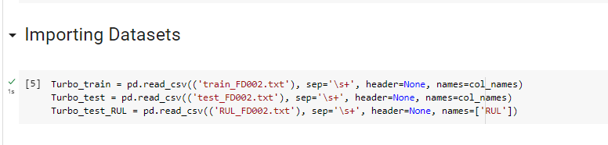

**Figure 4.3.1 Importing dataset**

(Obtained from Jupyter Notebook)

Researchers use the pandas package, which offers the read_csv() method, to load the data by reading the txt file into a DataFrame object. In a tabular format, this makes it simple for us to alter and analyse the data. Once researchers get a basic overview of the data, including the names of the columns and a few rows of real data, researchers can examine the data using the head() method.

A crucial stage in ensuring the data's quality is data cleansing. then verify the data for any missing values using the isnull() function, and then tally the number of missing values in each column using the sum() function. If any missing values are discovered, researchers take the proper action to manage them, which may include adding default values or eliminating any rows or columns that contain missing data. Several statistical methods offered by pandas, including describe(), mean(), median(), mode(), min(), and max(), are used to explore data. researchers may utilise the knowledge researchers receive from these functions to guide this decision-making throughout the analysis by gaining insights into the distribution and central tendency of the data.

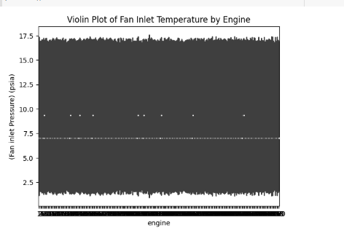

**Figure 4.3.1 Violin Plot of Fan Inlet Temperature by Engine**

(Obtained from Jupyter Notebook)

The above figure is showing Violin Plot of Fan Inlet Temperature by Engine which has been done to get the proper formation of visualstaion of the fan inlet pressure.

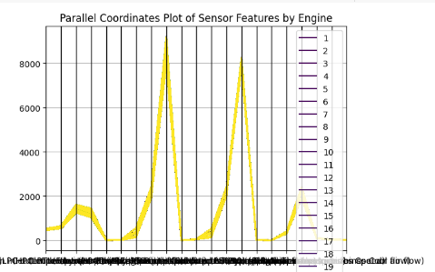

**Figure 4.3.1 Parallel Coordinates Plot of Sensor Features by Engine**

(Obtained from Jupyter Notebook)

The above sippet has been developed to get the Parallel Coordinates Plot of the sensor of the turbine air craft with respect to the engine.

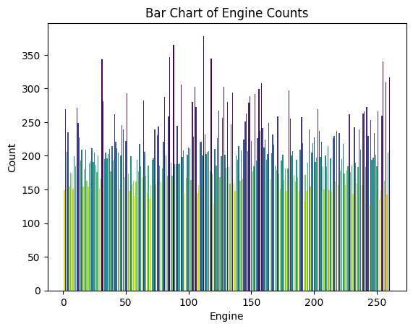

**Figure 4.3.1 Bar Chart of Engine Counts**

(Obtained from Jupyter Notebook)

The above bar cha has been counted earlar by declaring the function and later it has been visualised to get the proper information of the dataset.

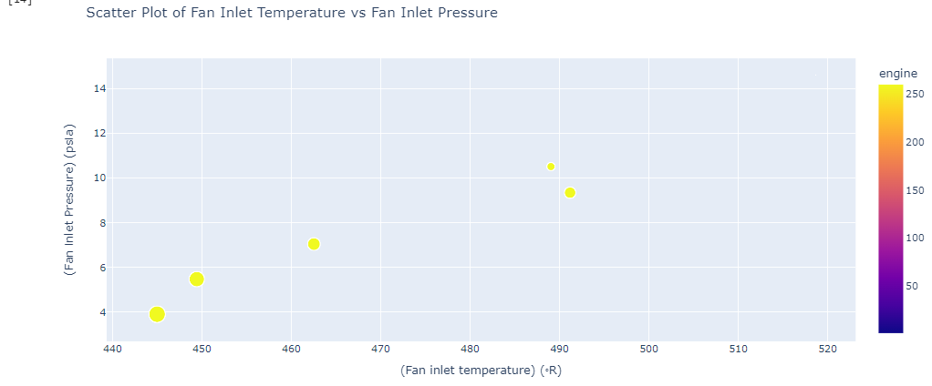

**Figure 4.3.1 Scatter Plot of Fan Inlet Temperature vs Fan Inlet Pressure**

(Obtained from Jupyter Notebook)

The above figure has been obtained in the jupyter notebook to get the proper visualsation of the Scatter Plot of Fan Inlet Temperature vs Fan Inlet Pressure. This gives a clear idea of the

Presure and temperature graph.

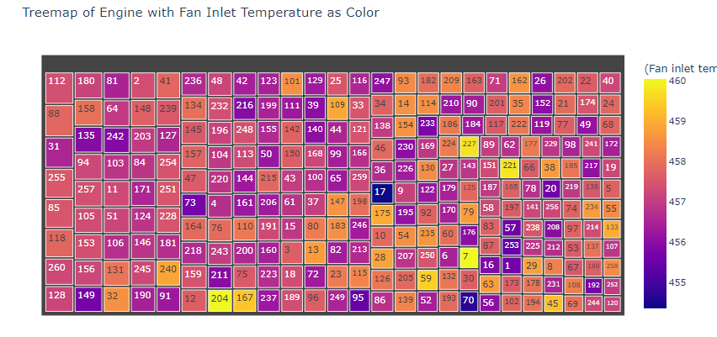

**Figure 4.3.1 Treemap of Engine with Fan Inlet Temperature as Color**

(Obtained from Jupyter Notebook)

The above picture is showing the Treemap of Engine with Fan Inlet Temperature as Color where the dark colour represent the more temperature and the light colour (yellow) shows the less tem,pure of the engine.

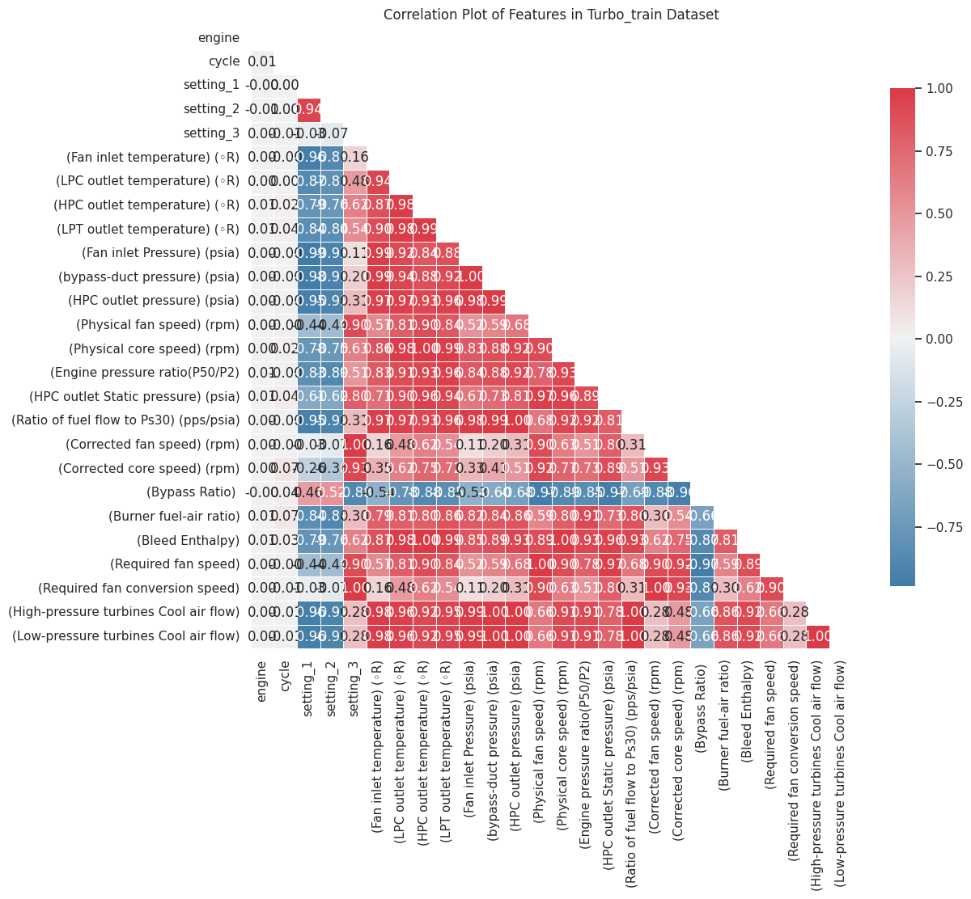

**Figure 4.3.1 Correlation Plot of Features in Turbo_train Dataset**

(Obtained from Jupyter Notebook)

The above figue is showing the Correlation Plot of Features in the test dataframe abd this shows the clear positive relation and neegtive relation of the data attributes.

A useful technique for visualising data is data visualisation. To understand how category and numerical data are distributed, researchers utilise the matplotlib and seaborn libraries to generate visualisations like bar charts, histograms, and box plots. These visualisations assist in this study by allowing us to see patterns and trends in the data.

A variety of methods are used in data analysis, including determining the correlations betresearchers en variables, running hypothesis tests using statistical libraries like scipy or statsmodels, and developing custom functions to carry out certain data analysis tasks.

### 4.3.4 Model training:

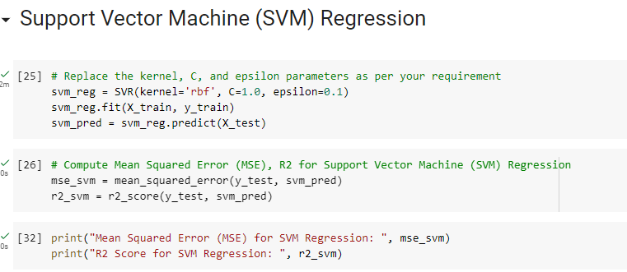

**Figure 4.3.1 Support Vector Machine (SVM) Regression**

(Obtained from Jupyter Notebook)

The above figure is represents the code block for training the ***“Support Vector Machine (SVM) Regression”*** model. Here, the computation of the mean squared error as well as R2 has been done.

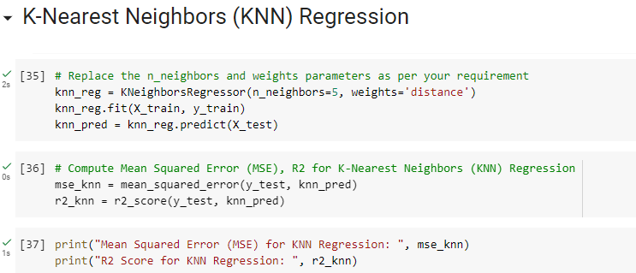

**Figure 4.3.1 K-Nearest Neighbors (KNN) Regression**

(Obtained from Jupyter Notebook)

This particular figure also represents the KNN regression model implementation and here the code block for determining the mean squared error as well as R2 has been represented.

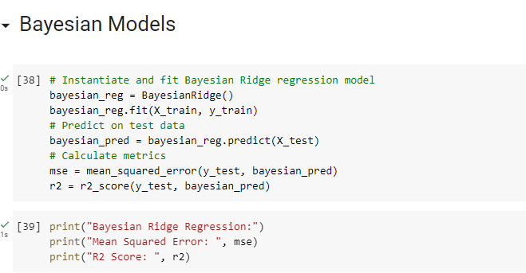

**Figure 4.3.1 Bayesian Ridge regression model**

(Obtained from Jupyter Notebook)

Here, in this above figure the process of fitting the “Bayesian Ridge regression model” has been represented and also, the prediction with the test data has been done.

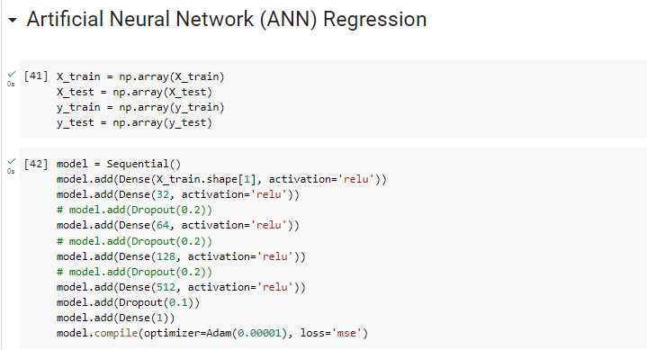

**Figure 4.3.1 Artificial Neural Network (ANN) Regression**

(Obtained from Jupyter Notebook)

Here, in this above figure for training the “Artificial Neural Network (ANN) Regression” model the model dropout, and the dense calculation has been done.

### 4.3.5 Model evaluation:

This model has been evaluated in the section to get the popper prediction of the dataset though the machine learning module. In this research there are several machine learning has been used such as ANN, SVM, Bayesian Ridge regression and K-Nearest Neighbors (KNN) Regression. This has been done by doing data pre-processing, data cleaning feature selctin and the model has been evaluated. Without this the model cant be evaluated the error has been detected.

### 4.3.6 Implementation:

This particular section of the case scenario has discussed the implementation process. Here, various model has been implemented to predict the aero engine performance. After implementing the models such as SVM, ANN and many others it has been found that the performance of the aero engine is determined accurately. The accuracy score, R2 score and RMSE score have been obtained from the model which has been implemented in the above programme.